Dear Partner!

Warsaw Convention Bureau is a department of Warsaw Tourism Organisation, a private-public association established by the Warsaw City Hall for the purpose of promoting Warsaw as an attractive destination for individual and business tourism. One of the goals of Warsaw Convention Bureau is to make large conferences, fairs and congresses happen in the city. As a part of this goal we offer support for both Polish and international meeting planners considering Warsaw for their events. By using the synergy of public and private entities associated in Warsaw Tourism Organisation we strive to provide each organiser with the below range of services.

Each request for support is individually evaluated and the decision on the scope of the support depends on a range of factors, such as the available resources of Warsaw Convention Bureau and its partners, as well as the economic impact and significance in terms of content and image of the event.

SUPPORT FOR THE LOCAL CONGRESS AMBASSADOR
If you are a member of Polish scientific community or a representative of a local industry association and you would like to acquire a significant international congress to Warsaw – here is how we can support you:
- Preparation for the destination pitch - analysis of the event in the ICCA international database, access to key information from international partners (convention bureaus, PCOs, partners of previous editions of the event), collection of offers for the logistics of the event (venues, hotels, PCOs/DMCs, etc.).
- Bid book – professional destination offer of Warsaw including all logistics and subject-related elements required by the official request for proposal issued by the meeting owner.
- Support from local partners - help with engaging Polish stakeholders whose active role in the bid preparation and event itself is required by the meeting owner or can be seen as providing added value to the Warsaw congress. These could be public institutions, authorities or key industry leaders (universities, institutes, representatives of state and local government, industry associations).
- Active help with presenting Warsaw offer to the decision makers – mostly it means accompanying local congress ambassador at an international congress where the Warsaw offer is presented in a professional way.
- Further promotion of the event – in order to acquire the largest possible attendance of the Warsaw congress Warsaw CvB will help local host committee with promoting Warsaw edition at the preceding meetings.

SUPPORT FOR THE EVENT ITSELF
Whether you are a Polish or an international meeting planner willing to organize a significant congress in the capital of Poland, Warsaw Convention Bureau will strive to provide your meeting with the following support:
- Acquiring a complimentary venue – offered by local authorities or stakeholders for the purposes of hosting welcome reception, gala dinner or parts of event itself.
- Acquiring a complimentary public transport tickets – offered by local authorities for all the participants for a whole duration of the event.
- Warsaw sightseeing tours for VIP guests – complimentary sightseeing tours for key participants of the event (usually 3-hours sightseeing with a guide, transfers and additional attractions).
- Keynote speaker sponsorship package – providing accommodation, sightseeing, dinner and a partial refund of travel expenses for the keynote of the Warsaw congress.
- Welcome stand at the Warsaw Chopin Airport – provided at complimentary basis for the arriving participants, along with staff and information materials (usually first 1-2 days of the event).
- Inviting local and state government representatives to take part in the most important part of the congress (opening ceremony, welcome dinner, panel sessions, etc.)
- Additional benefits from the members of Warsaw Tourism Organisation – depending on which and how many members of WTO are engaged in the event Warsaw CvB will always try to provide the meeting owner with additional benefits generated by the synergy of the local MICE industry.
- Promotion of and at the event – here is how we can help to promote the congress in Warsaw and promote Warsaw to the participants at the congress:
- Thanks to the cooperation with Warsaw City Hall, Warsaw CvB can help the effort to include information on the congress in the official Warsaw communication run by city hall press office, in the means of public transportation, etc.
- Full coverage of the event in the communication channels of Warsaw Convention Bureau (website, facebook, newsletter, official Warsaw MICE calendar)
- Providing Warsaw tourism promotional materials (brochures, maps, etc.) for the congress participants
- Promotional stand with tourism information during the event (English-speaking staff, printed materials, possible sales of trips and promotional gadgets).
- Chopin Lounge – help in arranging a dedicated space within the area of the event to promote Warsaw as a city of Chopin (Chopin mobile bench, music, albums, books, coffee break spot, etc.)
- Providing access to a large database of photos, movies and promotional descriptions about the city to be used by the meeting owner

We cordially welcome every meeting planner interested in cooperation on staging congresses, conferences, fairs and other business and scientific events in Warsaw. We will make every effort within the range of our possibilities to make your event in Warsaw a great success!

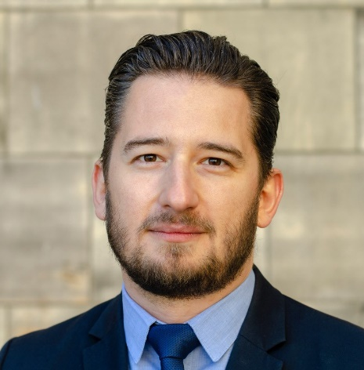
Mateusz Czerwiński
Vice President of the Board

Warsaw Tourism Organization
Warsaw Convention Bureau
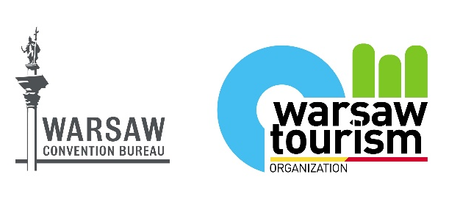
Palace of Culture and Science
9th floor, room. 937
Pl. Defilad 1, 00-901 Warszawa

Mob. +48 601 324 244
mateusz.czerwinski@wot.waw.pl
www.warsawconvention.pl

